**[Roasted Rainbow Carrots](http://feedproxy.google.com/~r/CavegirlCuisine/~3/Lp64vQQPTno/?utm_source=feedburner&utm_medium=email)**

Posted: 14 Aug 2014 09:12 AM PDT

These beautiful carrots were too gorgeous not to pick up. My girls loved eating carrots with a variety of colors.

**[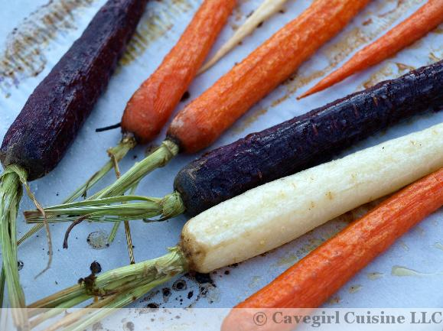](http://cavegirlcuisine.com/wp-content/uploads/2014/08/Roasted-Rainbow-Carrots.jpg)**

### Ingredients

* 1 bunch of rainbow carrots, peeled
* 1 tablespoon avocodo oil (or preferred cooking oil)
* 1 tablespoon pure maple syrup or melted raw honey
* 1 teaspoon vinegar (I used a balsamic vinegar here…use what you have!)
* sea salt, to taste

### Directions

1. Preheat oven to 400 degrees F. Line a baking sheet with aluminum foil or parchment paper.
2. Trim the green off the tops of the carrots. I like to leave about an inch of tops for the “pretty factor”.
3. In a bowl, combine oil, maple syrup, and vinegar. Whisk together. Brush mixture on carrots until everything is well-coated.
4. Spread carrots evenly onto baking sheet. Salt as desired.
5. Cook for 20-30 minutes depending on the girth of your carrots. Serve immediately.
6. Enjoy!